Filter Settings for Tree Manipulation

AbstractTreeManipulator:

Superclass of all classes that can manipulate the tree

BuildCustomTreeManipulator:

Manipulator used to build a tree out of selected relations

A manipulator that gets a hash set with node ids and builds a tree using only these ids. Therefore, it first must identify whether it is in the horizontal or vertical tree view and afterwards it loops through all visible nodes of its tree view and filters out the nodes that do not have their node ids in the hashset. Finally, the visible tree does only contain nodes that are listed in the hashset.

HideTreeNodesManipulator:

Manipulator used to hide nodes that do not have a relation

This tree manipulator first needs to find out whether it is used for the horizontal or vertical tree view. After finding this out, it loops over all visible nodes of both trees and finds nodes that do not have a relation to a node in the opposite tree view. These nodes are left out of the finally computed visible tree.

SortingTreeManipulator:

Manipulator used to sort tree nodes in ascending/descending alphanumerical order

This tree manipulator uses a Comparator to order the tree nodes either in ascending or descending alphanumerical order. Basically, it only changes the way the children of a node are returned.

TreeProxyManager:

Class used to manage all tree manipulators that are accessible through the context menu

For generating the final visible tree, the TreeProxyManager uses its root nodes and loops
over the list of registered tree manipulators. The different tree manipulators do not change the underlying root nodes, they change the savedVisibleTree of the TreeProxyManager. This ensures that the original nodes are not altered by the TreeProxyManager and can be used as base again.
The order of the tree manipulators is important! The first tree manipulator has to be the BuildCustomTreeManipulator, then the SortingTreeManipulators and finally the HideTreeNodesManipulator. Before all tree manipulators, there are as many DefaultTreeSynthesizers as there are root nodes. They are needed to build up the original tree using the original tree node data.
TreeProxyManager also implements the context menu that can be accessed by right-clicking on a tree view. It also handles the events generated by selecting items of the context menu and applies the changes to the underlying tree nodes.

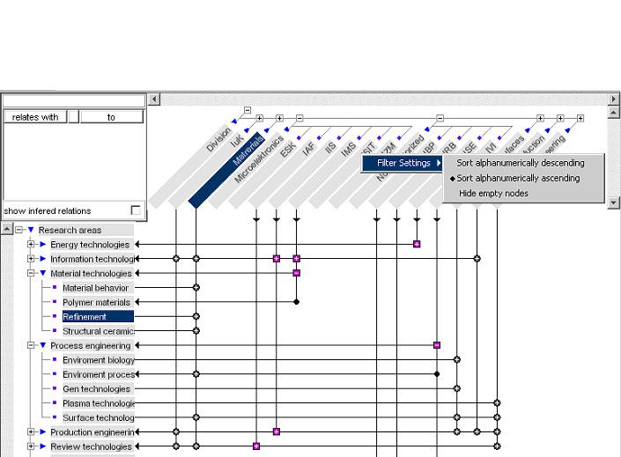
Figure 1: Ascending Order of Tree Nodes

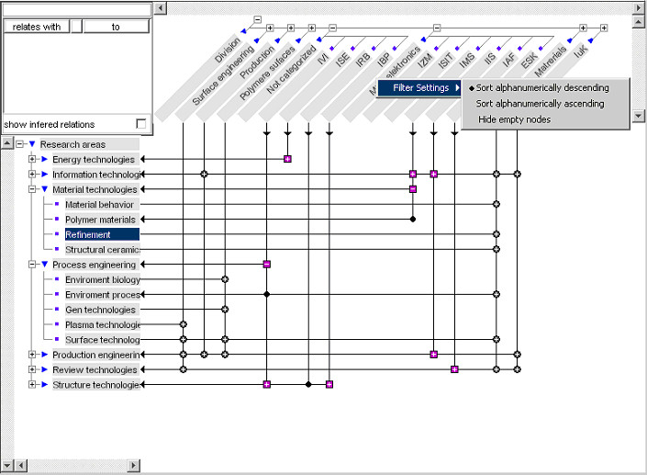
Figure 2: Descending Order of Tree Nodes

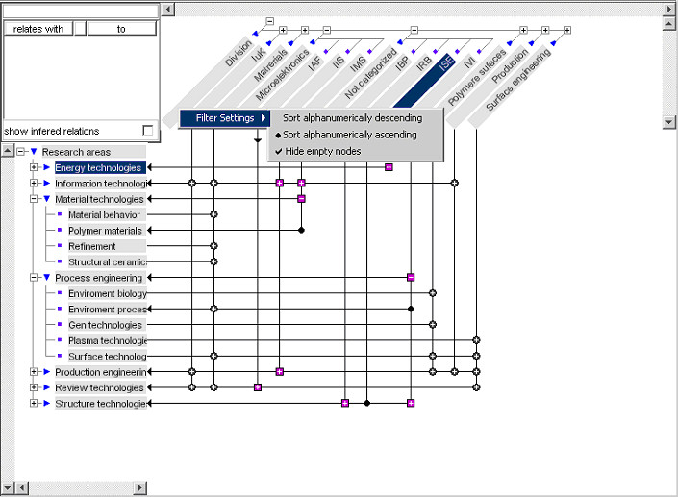
Figure 3: Hidden Tree Nodes

